SKILL WEEK-2

STEP 1: Open Ubuntu
Open Ubuntu from the Start menu.
You should see:
jhanasri@LAPTOP-1RN1M8E3:~$
If you're somewhere else, go to your home folder:
cd ~
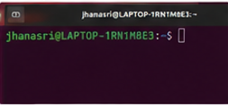

STEP 2: Create the OSSP folder
mkdir OSSP
Check:
ls
You should see
OSSP
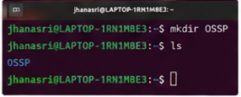

STEP 3: Enter the folder
cd OSSP
Verify:
pwd
Output:
/home/jhanasri/OSSP
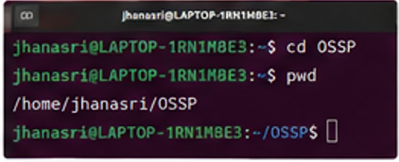

STEP 4: Initialize Git
git init
Expected output:
Initialized empty Git repository...
This creates the hidden .git directory automatically.
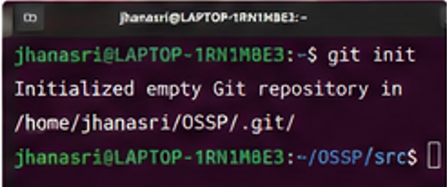

STEP 5: Create folders
Run one command:
mkdir src include obj bin docs tests scripts assets
Check:
ls
You should see
assets
bin
docs
include
obj
scripts
src
Tests
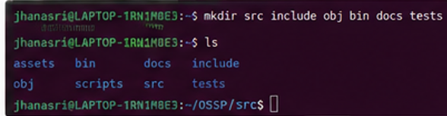

STEP 6: Create project files
Run:
touch README.md LICENSE Makefile .gitignore
Check:
Ls
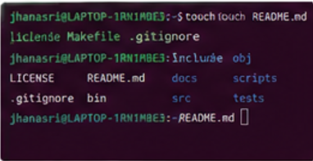

STEP 7: Create source files
touch src/main.c
touch src/shell.c
touch src/parser.c
touch src/executor.c
touch src/builtin.c
Check:
ls src
Expected:
builtin.c
executor.c
main.c
parser.c
Shell.c
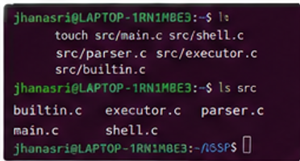

STEP 8: Create header files
touch include/shell.h
touch include/parser.h
touch include/executor.h
touch include/builtin.h
Check:
ls include
Expected:
builtin.h
executor.h
parser.h
Shell.h
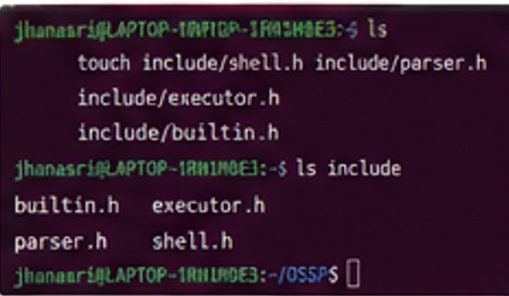

STEP 9: Create documentation files
touch docs/design.md
touch docs/report.pdf
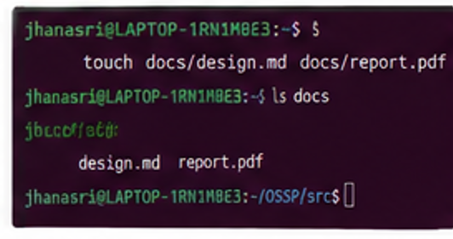

STEP 10: Create test files
touch tests/test_parser.c
touch tests/test_executor.c
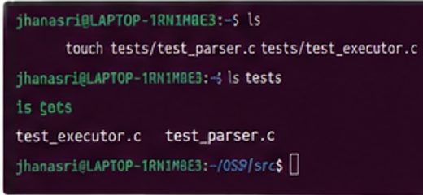

STEP 11: Create helper script
touch scripts/run.sh
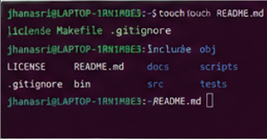

STEP 12: Create image placeholder
touch assets/architecture.png
The document lists this image under assets/; creating an empty placeholder file satisfies the required structure.
STEP 13: Check the complete structure
Run:
tree
If you get:
tree: command not found
Install it:
sudo apt install tree -y
Then run:
tree
You should see a structure similar to:
OSSP
├── assets
│ └── architecture.png
├── bin
├── docs
│ ├── design.md
│ └── report.pdf
├── include
│ ├── builtin.h
│ ├── executor.h
│ ├── parser.h
│ └── shell.h
├── obj
├── scripts
│ └── run.sh
├── src
│ ├── builtin.c
│ ├── executor.c
│ ├── main.c
│ ├── parser.c
│ └── shell.c
├── tests
│ ├── test_executor.c
│ └── test_parser.c
├── .gitignore
├── LICENSE
├── Makefile
└── README.md

STEP 14: Verify Git
Run:
git status
You should see that Git has detected the new files.

Step 15: Open the src folder
cd ~/OSSP/src

Step 16: Create a new C file
touch fork_exec.c
Check:
ls

Step 17: Open the file
nano fork_exec.c

Step 18: Paste this code
#include <stdio.h>
#include <stdlib.h>
#include <unistd.h>
#include <sys/wait.h>

int main()
{
char command[100];

printf("Enter Linux Command: ");
scanf("%s", command);

pid_t pid = fork();

if(pid < 0)
{
printf("Fork Failed!\n");
return 1;
}
else if(pid == 0)
{
printf("Child Process\n");
printf("Child PID = %d\n", getpid());

execlp(command, command, NULL);

printf("Command Not Found!\n");
}
else
{
wait(NULL);

printf("Parent Process\n");
printf("Parent PID = %d\n", getpid());
}

return 0;
}

Step 19: Save the file
Press:
Ctrl + O
Press Enter
Then:
Ctrl + X

Step 20: Check whether GCC is installed
gcc --version
If you see a version number, continue.
If not, install it:
sudo apt install build-essential -y

Step 21: Compile the program
gcc fork_exec.c -o fork_exec

Step 22: Check the executable
ls
You should see:
fork_exec

Step 23: Run the program
./fork_exec

Step 24: Test with ls
Input:
ls

Step 25: Run again
./fork_exec
Input:
pwd

Step 26: Run again
./fork_exec
Input:
date

Step 27: Run again
./fork_exec
Input:
whoami

Step 28: View the process tree (optional but useful)
pstree
If pstree is not installed:
sudo apt install psmisc -y
Then run:
pstree

Step 29: Trace system calls (if required)
Run:
strace ./fork_exec
If strace is not installed:
sudo apt install strace -y
Then run the command again.

Step 30: Check Git status
cd ~/OSSP
git status

